

**Pre-Lab 1**

Name: Socheath Sok,

Class: EE 346 L

Section 6, T/Th

Date: September 03, 2018

**Last four digits of the I.D: 0701**

The target square is calculated using the number 07 and 01. Since both numbers are less than 20, the remainders after division are the same numbers with 07 represents the row and 01 represents the column. This square is marked with a red ‘X’ in the picture of the maze below. With requirements in mind, multiples paths were considered in order to find the shortest and easiest one possible for the bear to escape. The first design was the fastest path possible, but it failed due to the number of bees exceeding 15. As the result, a slightly longer path, which is shown below, is used. With the final design, the bear will pass through the target square, and go to the upper left side of the maze, where it needs to turn around after hitting a dead end at row 03 and column 01. After that, the bear will try to move to the right and hit a total of 15 bees before escaping. At each intersection, the square is marked by either number 1, 2, or 4 as a way to tell which side open and which is not. In the table on the next page as well as in the picture of the maze, the bear will have to take different actions at these intersections, and thus, satisfies our last requirement which needs the path to be non-deterministic.

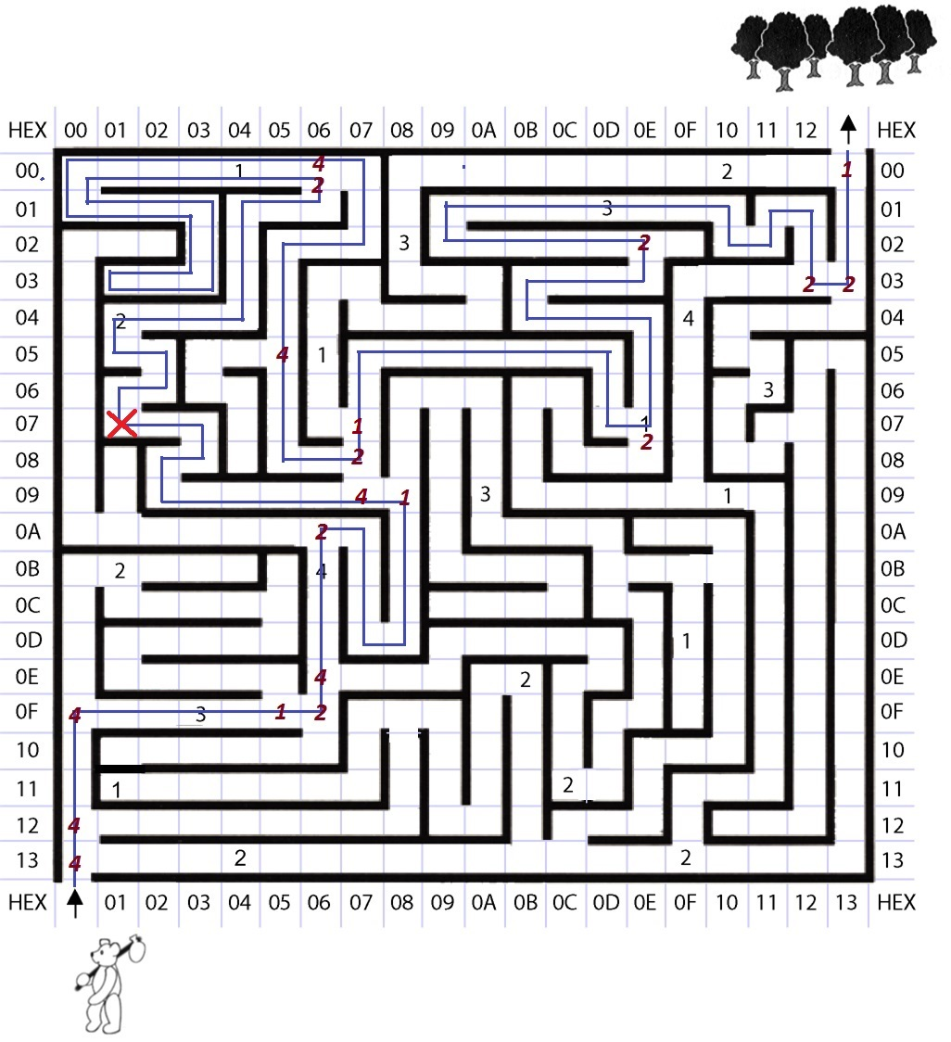

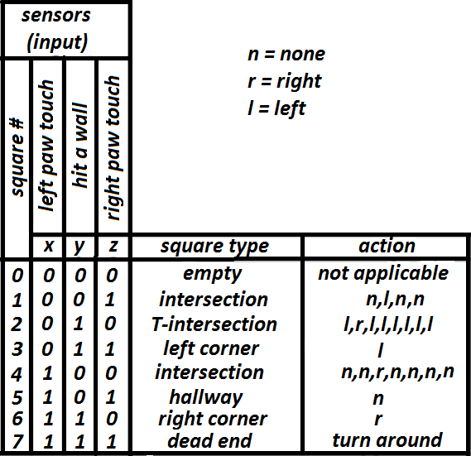

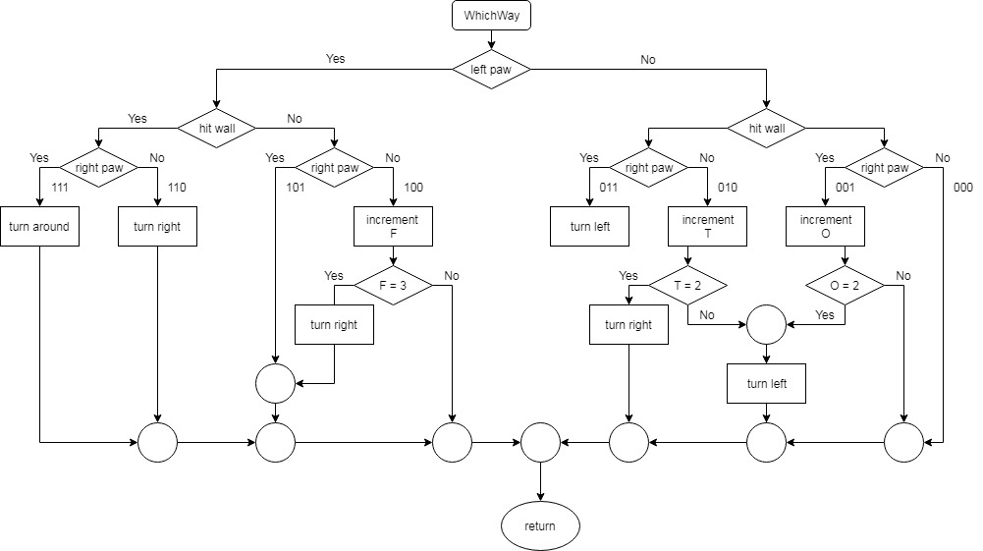

**Answer 1:** If switches 5 and 2 are on, segment ‘f’ and segment ‘c’ will light up.

**Answer 2:** In order to display the number 9 on the 7-segment display, switches 0, 1, 2, 3, 5, and 6 need to be on.

**Answer 3:**

|  | Binary | Decimal | Hexidecimal |
| --- | --- | --- | --- |
| **1** | *0111001* | **57** | *39* |
| **2** | **01010110** | *86* | *56* |
| **3** | *11110001* | *241* | **F1** |
| **4** | *10101101* | **173** | *AD* |
| **5** | *01111101* | *125* | **7D** |